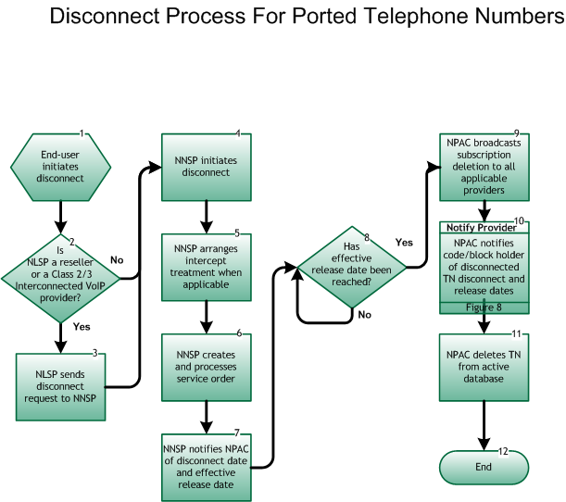

**Step 1:  End User initiates disconnect**

* The End User provides disconnect date and negotiates intercept treatment with current SP.

**Step 2:  Is NLSP a Reseller or Class 2 or 3 Interconnected VoIP Provider?**

* If Yes, go to Step 3.
* If No, go to Step 4.

**Step 3:  NLSP sends disconnect request to NNSP**

* Current Local SP sends disconnect request to current Network SP, per inter-company processes.

**Step 4:  NNSP initiates disconnect**

* NNSP initiates disconnect of service based on request from NLSP or End User.
* NNSP initiates disconnect of service based on regulatory authority(s).

**Step 5:  NNSP arranges intercept treatment when applicable**

* NNSP arranges intercept treatment as negotiated with the end user, or, when the disconnect is SP initiated, per internal processes.

**Step 6:  NNSP creates and processes service order**

* NNSP follows existing internal process flows to ensure the disconnect within its own systems.

**Step 7:  NNSP notifies NPAC of disconnect date1 and indicates effective release date2**

* NNSP notifies NPAC of disconnect date via the SOA interface and indicates effective release date, which defines when the broadcast occurs.
* If no effective release date is given, the broadcast from the NPAC is immediate.  The maximum interval between disconnect date and effective release date is 18 months.

**Step 8:  Has effective release date been reached?**

* If Yes, go to Step 9.
* If No, repeat Step 8

**Step 9:  NPAC broadcasts subscription deletion to all applicable providers**

* On effective release date, the NPAC broadcasts SV deletion to all applicable SPs via the LSMS interface.

**Step 10:  Notify Provider – NPAC notifies code/block holder of disconnected TN(s), disconnect and release dates**

* On effective release date, the NPAC notifies code/block holder of the disconnected TN(s), effective release and disconnect dates via the SOA interface. [**Reseller/Interconnected VoIP Provider/Type 1 Notification, Figure 8.**](https://numberportability.com/industry-info/lnpa-working-group/nanc-lnp-process-flows/reseller-interconnected-voip-provider-type-1-notification-process)

**Step 11:  NPAC deletes TN(s) from active database**

* On effective release date, the NPAC removes telephone number from NPAC database.

**Step 12:  End**

**Footer**

1  Disconnect Date:  Date the telephone number or numbers are no longer associated between an End User and the current Service Provider.

2  Effective Release Date:  Date the telephone number reverts back to NPA/NXX holder/owner.