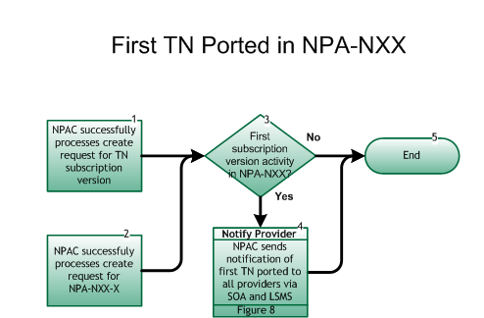

Step 1: NPAC successfully processes create request for TN subscription version
- SP notifies the NPAC of SV creation for a TN in an NPA-NXX.

Step 2: NPAC successfully processes create request for NPA-NXX-X
- NPAC successfully processes an NPA-NXX-X for a Number Pool Block.

Step 3: First Subscription Version activity in NPA-NXX?
- If Yes, go to Step 4.
- If No, go to Step 5.

Step 4: Notify Provider – NPAC sends notification of first TN ported to all providers via SOA and LSMS
- When the NPAC receives the first SV create request in an NPA-NXX, it will broadcast a “heads-up” notification to all SPs via the SOA and LSMS interfaces. Upon receipt of the NPAC message, all SPs will complete the opening for the NPA-NXX code for porting in all switches.
- Reseller/Interconnected VoIP Provider/Type 1 Notification, Figure 8.

Step 5: End

