NANC 437

Multi-Vendor NPAC SMS Solution
Origination Date :01/08/2009
Originator:Telcordia

Description:
The original request(s) to provide NPAC services was more than twelve years ago. Since that initial selection of two providers, the industry hasn’t had any choice in NPAC vendors. In all other aspects of number portability in North America, Service Providers have a choice of vendors. The Telecommunications Act implemented vendor competition as well, and the FCC specifically favored competition in NPAC services in originally approving multiple NPAC administrators. The FCC noted in the order that competition between vendors for NPAC would stimulate innovation and it would provide the other expected benefits of competition, including economic benefits and enhanced service levels. Since that order, the NPAC has become more critical to Service Provider networks with the addition of pooling and the pending change orders for URI information. The transactions at NPAC continue to grow at a large rate. If the rate of transaction growth continues, NPAC billable transaction will exceed more than one billion annually before the expiration of the current contract. Carrier choice in NPAC services can and should be implemented now to provide the benefits of competition to Service Providers before the NPAC grows so large that a transition would be higher risk than desirable.
Competition will lead not only to carrier choice but vendor diversity. In the current economic conditions, having multiple vendors versus a single source contract to support critical infrastructure services is becoming more essential. Multiple vendors assure business continuity of services in the event of vendor business failure. This diversity will not only reduce the business risk of these services being delivered in an uninterrupted manner but will also enhance the commercial management of the vendors. Carriers have experienced that multi sourced services and associated carrier choice results in more competitive pricing. Multiple competitive vendors also offer faster response to industry needs with more innovative services that further enhance the service currently being offered. The current NPAC service is working effectively, but opening it up to competition and carrier choice can only result in enhanced benefits to the industry. Selecting two or more vendors will drive the benefits to the users of a multi vendor solution that will result in carriers in each region being able to choose their vendor based on the values it offers in savings and enhanced services.
In summary, especially in today’s economic conditions, carriers more than ever need the benefits of competition that include:
- Carrier Choice
- Vendor Diversity
- Enhanced and Innovative Services
- Reduced Costs to the Industry
Description of Change:
While a Multi-Vender NPAC Solution, hereafter referred to as Multi-Administrator Peering Model, and impacts the NPAC SMS, the technical approach described in this change order minimizes the impacts to Service Provider systems and operations.
The following high-level peering technical implementation goals related to Service Providers and the NPAC Services provided under a Multi-Administrator Peering Model implementation:
- No SOA and LSMS to NPAC SMS CMIP Interface Modifications
- No User LTI GUI Changes
- Minimize Service Provider operational changes
- Limit Service Provider operational interactions to only their chosen NPAC vendor
- Limit NPAC to NPAC connections to reduce complexity
- Allow communication of all NPAC data for network data and active subscription versions
- Support any additional information needed for Inter-NPAC SMS porting events
The following diagram illustrates the Solution approach proposed in this change order by showing a Multi-Administrator Peering Model with two NPAC SMS to visually introduce the terminology used:
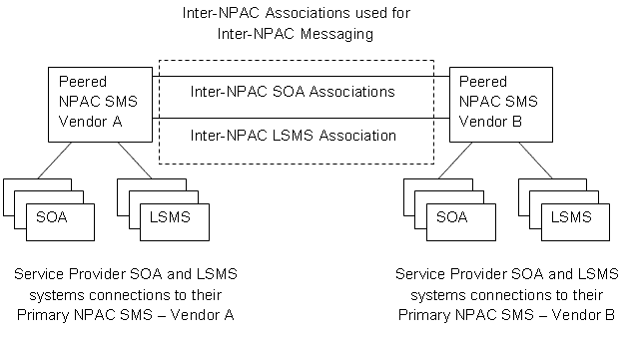
Inter-NPAC Associations used for Inter-NPAC Messaging
The terminology used in the diagram is defined as follows:
- Primary NPAC SMS – The NPAC SMS that provides service directly to a specific Service Provider SOA, LSMS, or LTI GUI for a transaction.
- Peered NPAC SMS – An NPAC SMS system that communicates with another NPAC SMS in the same Region in a Multi-Administrator Peering Model.
- Inter-NPAC Peering – The Multi-Administrator Peering Model implementation discussed in this solution document that leverages the existing SOA to NPAC SMS and LSMS to NPAC SMS CMIP interface for Inter-NPAC SMS messaging
- Inter-NPAC SMS Messaging – CMIP messaging between Peered NPAC SMS systems within the same Region as a result of Service Provider activity initiated from the LTI GUI, SOA, and/or LSMS interface connections. Inter-NPAC messages include all messages required for completion of requests.
- Inter-NPAC SMS Associations – CMIP associations between Peered NPAC SMS
- Inter-NPAC SMS LSMS Association – A CMIP association between two Peered NPAC SMSs that is used to communicate LSMS activity such as Subscription Version activation and Network Data creation from a Primary NPAC SMS to a Peered NPAC SMS.
- Inter-NPAC SMS SOA Association – A CMIP association between two Peered NPAC SMSs that is used to communicate SOA activity, such as porting activity between Service Providers in different Peered NPAC SMS.
Major points/processing flow/high-level requirements:
Inter-NPAC Peering leverages the existing SOA to NPAC SMS and LSMS to NPAC SMS CMIP interface for Inter-NPAC SMS messaging. This approach simplifies implementation of the Inter-NPAC SMS messaging and does not require the introduction of a different messaging protocol. While interface impacts for Inter-NPAC Peering are avoided for the existing Service Provider SOA and LSMS to NPAC SMS interfaces, additional data would need to be communicated between peered NPAC SMS systems to improve efficiency. Areas for extensions to Inter-NPAC SMS messaging will be identified in the detailed specifications to be provided.
Two diagrams are provided to give a high level view of the interactions for that would occur between Peered NPAC SMS in a Multi-Administrator Peering Model for porting activity between two Service Providers. The two types of ports that are described are an Intra NPAC Port and an Inter NPAC Port.
Intra-NPAC SMS Port
A port is an Intra-NPAC SMS port when only one NPAC SMS serves both of the Service Providers involved in a port. The following diagram depicts a port with both Service Providers being customers of the same NPAC SMS:
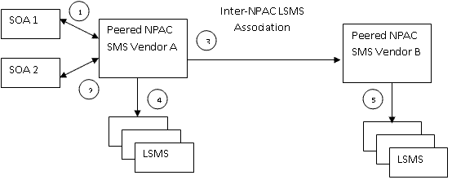
Inter-NPAC LSMS Association
Service Providers porting in the same NPAC SMS (Intra-NPAC port):
- SOA 1 and SOA 2 served by Vendor A create a pending port for the TN porting form SOA 2
- SOA 1 activates the TN on the due date
- TN Activation broadcast is sent to the peered Vendor B
- TN Activation broadcast is sent to LSMS’ serviced by Vendor A
- TN Activation broadcast is sent to LSMS’ serviced by Vendor B
Inter-NPAC SMS Port
A port is an Inter-NPAC SMS port when each NPAC SMS serves one of the Service Providers involved in a port. The following diagram depicts a port with both Service Providers being customers of different NPAC SMS:
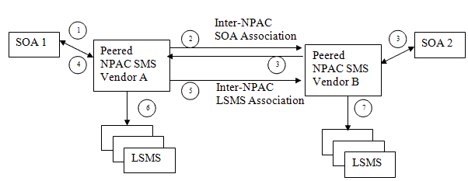
Inter-NPAC SOA Association
Service Providers porting in the different NPAC SMS ( Inter-NPAC):
- SOA 1 serviced by Vendor A creates a pending port for a TN porting from SOA 2
- Vendor A forwards the create request to Vendor B that serves SOA 2
- Vendor B creates the pending subscription version and sends notifications to both SOA 1 and SOA 2
- SOA 1 activates the TN on the due date (SOA 2 concurrence is not shown to reduce complexity of the diagram)
- TN Activation broadcast is sent from Vendor A to the peered Vendor B
- TN Activation broadcast is sent to the LSMS’ served by Vendor A
- TN Activation broadcast is sent to LSMS’ served by Vendor B
Requirements:
- TBD

IIS:
- TBD
GDMO:
- TBD
ASN.1:
- TBD
Func Backward Compatible: TBD
Jan ’09 LNPAWG discussion:
A walk-thru of the proposed solution took place. Telcordia will be providing addition information prior to the Mar ’09 LNPAWG meeting.
Mar ’09 LNPAWG, discussion:
A walk-thru of some of the documents provided in Feb were reviewed. Further review will take place during the Apr con call, and the May face-to-face mtgs.
May ’09 – Jul ‘10 LNPAWG discussion:
The group has continued reviews during the monthly mtgs.
Final Resolution:
Open
Related Release:
TBD
Status: Closed

