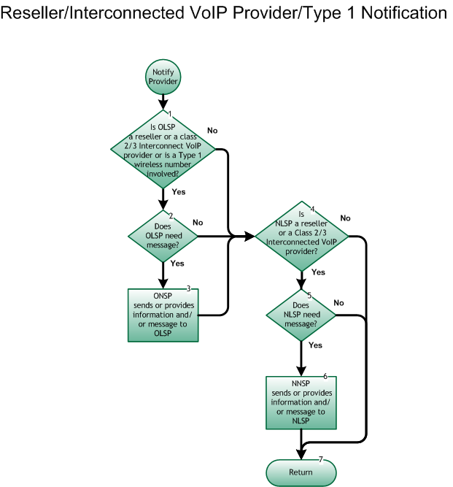

Step 1: Is OLSP a Reseller or a Class 2 or 3 Interconnected VoIP Provider or is a Type 1 wireless number involved?
- If Yes, go to Step 2.
- If No, go to Step 4.

Step 2: Does OLSP need message?
- If Yes, go to Step 3.
- If No, go to Step 4.

Step 3: ONSP sends or provides information and/or message to OLSP
- ONSP (Network Provider) sends or provides information and/or message to the OLSP (Reseller or Class 2/3 Interconnected VoIP Provider or wireline provider providing Type 1 arrangement) fulfilling all requirements of any service agreement between the involved service providers.

Step 4: Is NLSP a Reseller or Class 2 or 3 Interconnected VoIP Provider?
- If Yes, go to Step 5.
- If No, go to Step 7.

Step 5: Does NLSP need message?
- If Yes, go to Step 6.
- If No, go to Step 7.

Step 6: NNSP sends or provides information and/or message to NLSP
- NNSP (Network Provider) sends or provides information and/or message to the NLSP (Reseller or Class 2 or 3 Interconnected VoIP Provider) fulfilling all requirements of any service agreement between the involved service providers.

Step 7: Return
- Return to previous flow.

