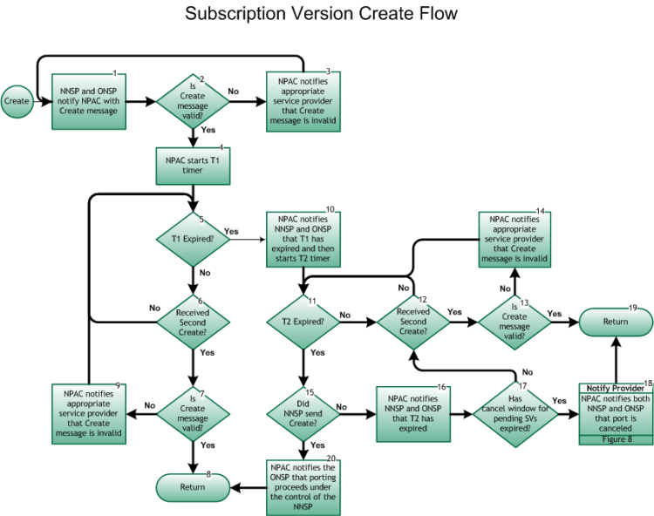

NOTE: The following redlines were approved by LNPA WG in the March 6, 2013 meeting, and will be presented for approval to the NANC in their May 2013 meeting, and if approved at the NANC, will then be sent to the FCC for approval.

Step 1: NNSP and ONSP Notify NPAC with Create message
- Due date of the SV Create message is the due date on the FOC, where wireline due date equals date and time normalized to 00:00:00, and wireless due date equals date and time. For porting between wireless and wireline, the wireline due date format applies. Any change of due date in the NPAC must be a result of a change in the FOC due date. Exceptions may be made upon agreement between the porting parties (NNSP and ONSP).
- SPs enter SV data into the NPAC via the SOA interface for porting of End User in accordance with the NANC FRS and the NANC IIS.
- The NPAC/SMS expects to receive matching SV Create messages from the ONSP and the NNSP when facilitating porting of a telephone number. However, to prevent the possibility of the ONSP unnecessarily delaying a port, two timers were developed and referred to as T1 and T2. If the ONSP does not send a matching SV create message (indicating either concurrence or conflict) to the NPAC, once both the T1 and T2 timers expire the NNSP can proceed with porting the telephone number on the FOC due date (SV Due Date). Exceptions may be made upon agreement between the porting parties (NNSP and ONSP) allowing earlier activation.
While some service providers choose not to send the concurring SV Create, but rather allow the timers to expire, the LNPA Working Group concludes that all service providers should send the matching SV Create messages to the NPAC/SMS. This will facilitate expeditious porting of telephone numbers and is more efficient than merely allowing timers to expire. The increased efficiency is especially beneficial in meeting the FCC mandated 1-day interval for Simple Ports.
[Note that the order in which the ONSP and NNSP Create messages arrive at the NPAC/SMS is immaterial.]
- With regard to the population of the Due Time on the NNSP and ONSP NPAC Create messages, current industry practices for both Mechanized SOA and Low Tech Interface (LTI) users will be maintained for Simple Ports.
- NNSP may not activate a port before midnight (00:00:00) local time of the FOC due date (SV Due Date) unless it has been verified with the ONSP that the port could be activated early without impacting the customer's service, or an earlier due date has been agreed to between the porting parties (ONSP and NNSP). Failing to verify first that the ONSP has completed all necessary steps in the port-out process, e.g., established the 10-Digit Unconditional Trigger, resolved any order fallout in systems, etc., could result in the customer's service being negatively impacted, such as inability to receive all of their calls.

Step 2: Is Create message valid?
- NPAC validates data to ensure value formats and consistency as defined in the FRS. This is not a comparison between NNSP and ONSP messages.
- If Yes, go to Step 4. If this is the first valid create message, the T1 Timer (Initial Concurrence Window tunable parameter) is started. SV Create Notifications are sent to both the ONSP and NNSP.
- If No, go to Step 3.

Step 3: NPAC notifies appropriate Service Provider that create message is invalid
- If the data is not valid, the NPAC sends error Notification to the SP for correction.
- The SP, upon Notification from the NPAC, corrects the data and resubmits to the NPAC. Re-enter at Step 1.

Step 4: NPAC starts T1 timer
- Upon receipt of the first valid create message, the NPAC starts the T1 Timer (Initial Concurrence Window tunable parameter). The value for the T1 Timer is configurable (one of three values) for SPs. Wireline and Intermodal ports will use either long or medium timers. The current value for the long timer (typically any wireline-involved Non-Simple porting) is nine (9) NPAC business hours. The current value for the medium timer (typically any wireline-involved Simple porting) is three (3) NPAC business hours. The current value for the short timer (typically wireless-to-wireless porting) is one (1) NPAC business hour.

Step 5: T1 expired?
- Short business hours (for wireline-involved Non-Simple porting) are defined as 7a-7p CT Monday through Friday, excluding NPAC-defined Holidays (Business Day start at 13:00/12:00 GMT, duration of 12 hours).
- Medium business hours (for wireline-involved Simple porting) are defined as 7a-12a Monday through Friday, excluding NPAC-defined Holidays in the predominant time zone for each NPAC region (Business Day start at NE/MA/SE [eastern time zone] 12:00/11:00 GMT, MW/SW/Canadian [central time zone] 13:00/12:00 GMT, WE [mountain time zone] 14:00/13:00 GMT, WC [west coast time zone] 15:00/14:00 GMT, duration of 17 hours).
- Long business hours (for wireless-to-wireless porting) are planned for 9a-9p in the predominant time zone for each NPAC region (Business Day start – NE/MA/SE 14:00/13:00 GMT, MW/SW/Canadian 15:00/14:00 GMT, WE 16:00/15:00 GMT, WC 17:00/16:00 GMT, duration of 12 hours).
- Short Business Days are currently defined as Monday through Friday, except holidays, and Long Business Days are currently defined as Sunday through Saturday (seven days a week), except holidays. Holidays and business hours are defined for each NPAC Region.If Yes, go to Step 10.
- If No, go to Step 6.

Step 6: Received Second Create?
- If Yes, go to Step 7.
- If No, return to Step 5.

Step 7: Is Create message valid?
- If Yes, go to Step 8.
- If No, go to Step 9.

Step 8: Return to Figure 6
- The porting process continues.
- Return to Main Porting Flow Figure 6, Create Process, Step 6.

Step 9: NPAC notifies appropriate Service Provider that Create message is invalid
- The NPAC informs the SP of an invalid create. If necessary, the notified Service Provider coordinates the correction.
- Return to Step 5.

Step 10: NPAC notifies NNSP and ONSP that T1 has expired, and then starts T2 Timer
- The NPAC informs the NNSP and ONSP of the expiration of the T1 Timer.
- Upon expiration, the NPAC starts the T2 Timer (Final Concurrence Window tunable parameter).

Step 11: T2 Expired?
- The NPAC provides a T2 Timer (Final Concurrence Window tunable parameter) that is defined as the number of hours after the expiration of the T1 Timer.
- The value for the T2 Timer is configurable (one of three values) for SPs. Wireline and Intermodal ports will use either long or medium timers. The current value for the long timer (typically any wireline-involved Non-Simple porting) is nine (9) NPAC business hours. The current value for the medium timer (typically any wireline-involved Simple porting) is three (3) NPAC business hours. The current value for the short timer (typically wireless-to-wireless porting) is one (1) NPAC business hour.
- Short business hours (for wireline-involved Non-Simple porting) are defined as 7a-7p CT Monday through Friday, excluding NPAC-defined Holidays (Business Day start at 13:00/12:00 GMT, duration of 12 hours).
- Medium business hours (for wireline-involved Simple porting) are defined as 7a-12a Monday through Friday, excluding NPAC-defined Holidays in the predominant time zone for each NPAC region (Business Day start at NE/MA/SE [eastern time zone] 12:00/11:00 GMT, MW/SW/Canadian [central time zone] 13:00/12:00 GMT, WE [mountain time zone] 14:00/13:00 GMT, WC [west coast time zone] 15:00/14:00 GMT, duration of 17 hours).
- Long business hours (for wireless-to-wireless porting) are planned for 9a-9p in the predominant time zone for each NPAC region (Business Day start – NE/MA/SE 14:00/13:00 GMT, MW/SW/Canadian 15:00/14:00 GMT, WE 16:00/15:00 GMT, WC 17:00/16:00 GMT, duration of 12 hours).
- Short Business Days are currently defined as Monday through Friday, except holidays, and Long Business Days are currently defined as Sunday through Saturday (seven days a week), except holidays. Holidays and business hours are defined for each NPAC Region.If Yes, go to Step 15.
- If No, go to Step 12.

Step 12: Receives Second Create?
- If Yes, go to Step 13.
- If No, return to Step 11.

Step 13: Is Create message valid?
- If Yes, go to Step 19.
- If No, go to Step 14

Step 14: NPAC notifies appropriate service provider that Create message is invalid
- The NPAC notifies the service provider that errors were encountered during the validation process.
- Return to Step 11

Step 15: Did NNSP send Create?
- If Yes, go to Step 20.
- If No, go to Step 16

Step 16: NPAC notifies NNSP and ONSP that T2 has expired
- The NPAC notifies both NNSP and ONSP of T2 expiration.

Step 17: Has cancel window for pending SVs expired?
- If Yes, go to Step 18.
- If No, return to Step 12

Step 18: Notify Provider – NPAC notifies NNSP and ONSP that port is canceled
- The SV is canceled by NPAC by tunable parameter (30 days). Both SPs take appropriate action related to internal work orders.
- For the Notification process, refer to Inter-Service Provider LNP Operations Flows – Reseller/Interconnected VoIP Provider/Type1 Notification, Figure 8.

Step 19: Return to Figure 6
- Return to Main Porting Flow Figure 6, Create Process, Step 6.

Step 20: NPAC notifies ONSP that porting proceeds under the control of the NNSP
- A Notification message is sent to the ONSP noting that the porting is proceeding in the absence of any message from the ONSP.

