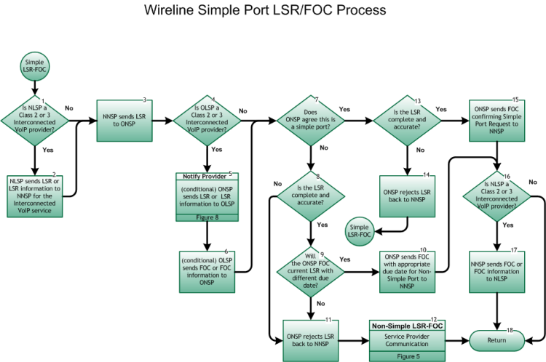

Step 1: Is NLSP a Class 2 or Class 3 Interconnected VoIP Provider?
- If Yes, go to Step 2.
- If No, go to Step 3.

Step 2: NLSP sends LSR or LSR information to NNSP for the Interconnected VoIP service
- NLSP sends an LSR or LSR Information to the NNSP fulfilling all requirements of any service agreement between the involved service providers. The LSR process is defined by the Ordering and Billing Forum (OBF) and the electronic interface by the Telecommunications Industry Forum (TCIF).

Step 3: NNSP sends LSR to ONSP
- The NNSP notifies the ONSP of the port using the LSR and sends the information via an electronic gateway, FAX, email, or manual means. The LSR process is defined by the Ordering and Billing Forum (OBF) and the electronic interface by the Telecommunications Industry Forum (TCIF).
- NOTE: The New SP (the NLSP and/or the NNSP whichever is applicable) must make every reasonable effort to verify that the port request is in fact a Simple Port request, e.g., pulling a CSR if available, or asking the appropriate questions of the end user, etc.

Step 4: Is OLSP a Class 2 or Class 3 Interconnected VoIP Provider?
- If Yes, go to Step 5
- If No, go to Step 7

Step 5: Notify Provider – (conditional) ONSP sends LSR or LSR information to OLSP (Figure 8)
- ONSP sends an LSR, LSR Information to the OLSP) fulfilling all requirements. The LSR process is defined by the Ordering and Billing Forum (OBF) and the electronic interface by the Telecommunications Industry Forum (TCIF). (conditional, based on any service agreement between the involved service providers)
- Communication between the ONSP and the OLSP with regard to the port must not delay the validation or processing of the port request.

Step 6: OLSP sends FOC or FOC information to ONSP (conditional)
- The OLSP notifies the ONSP of the port using the FOC and sends the information via an electronic gateway, FAX, email, or other means. The LSR/FOC process is defined by the Ordering and Billing Forum (OBF) and the electronic interface by the Telecommunications Industry Forum (TCIF). The information required on the FOC may vary based on the carriers involved. (conditional, based on any service agreement between the involved service providers)
- Communication between the ONSP and the OLSP with regard to the port must not delay the validation or processing of the port request.

Step 7: Does ONSP agree this is a Simple Port?
- If Yes, go to step 13.
- If No, go to step 8.

Step 8: Is the LSR complete and accurate?
- If Yes, go to step 9.
- If No, go to step 11.

Step 9: Will the ONSP FOC current LSR with a different Due Date?
- If Yes, go to Step 10.
- If No, go to Step 11.

Step 10: ONSP sends FOC with appropriate Due Date for Non-Simple Port to NNSP
- ONSP sends the Firm Order Confirmation (FOC, local response) with the appropriate Due Date for Non-Simple Port to the NNSP for the porting LSR.
- For wireline-to-wireline ports, and ports between wireline and wireless service providers, the following requirements apply for the interval to respond to an LSR:
- If the New SP-requested due date is 1-2 Business Days after LSR receipt, the Firm Order Confirmation (FOC) or Reject (whichever is applicable) is due within 4 hours. Refer to the attached chart for LSR Response Due Time:
- If the New SP-requested due date is 3 or more Business Days after LSR receipt, the Firm Order Confirmation (FOC) or Reject (whichever is applicable) is due within 24 clock hours, excluding weekends and Old Service Provider-defined holidays.
- In instances where the LSR indicates the port request is Non-Simple based on the current FCC definition and rule for a Simple Port, the Old SP must return a FOC or appropriate response within 24 clock hours, excluding weekends and Old Service Provider-defined holidays.
- It is the responsibility of the ONSP to contact the NNSP if the ONSP is unable to meet the required interval for transmitting the FOC. If the FOC is not received by the NNSP within the required interval, then the NNSP may contact the ONSP.
- The LSR/FOC process is defined by the Ordering and Billing Forum (OBF) and the electronic interface by the Telecommunications Industry Forum (TCIF). The information required on the FOC may vary based on the carriers involved.

Step 11: ONSP rejects LSR back to NNSP.
- The ONSP has determined that this is a Non-Simple Port request and does not FOC with a Due Date that is appropriate for a Non-Simple Port. As a result, the ONSP rejects the LSR back to the NNSP in the appropriate timeframe indicated in Step 10.

Step 12: NON-SIMPLE LSR-FOC – Service Provider Communication
- Inter-Service Provider LNP Operations Flows - Wireline Non-Simple Port LSR/FOC Process, Figure 5, Step 1.

Step 13: Is the LSR complete and accurate?
- If Yes, go to Step 15.
- If No, go to Step 14.

Step 14: ONSP rejects LSR to NNSP.
- ONSP sends a Reject Notification to the NNSP due to insufficient data on the LSR.
- Return to Figure 4, Step 1.

Step 15: ONSP sends FOC confirming Simple Port Request to NNSP.
- ONSP sends the Firm Order Confirmation (FOC, local response) to the NNSP for the porting LSR.
- For wireline to wireline ports, and ports between wireline and wireless service providers, the following requirements apply for the interval to respond to an LSR:
- If the New SP-requested due date is 1-2 Business Days after LSR receipt, the Firm Order Confirmation (FOC) or Reject (whichever is applicable) is due within 4 hours. Refer to file provided above for LSR Response Due Time:
- If the New SP-requested due date is 3 or more Business Days after LSR receipt, the Firm Order Confirmation (FOC) or Reject (whichever is applicable) is due within 24 clock hours, excluding weekends and Old Service Provider-defined holidays.
- In instances where the LSR indicates the port request is Non-Simple based on the current FCC definition and rule for a Simple Port, the Old SP must return a FOC or appropriate response within 24 clock hours, excluding weekends and Old Service Provider-defined holidays.
- The LSR/FOC process is defined by the Ordering and Billing Forum (OBF) and the electronic interface by the Telecommunications Industry Forum (TCIF). The information required on the FOC may vary based on the carriers involved.

Step 16: Is NLSP a Class 2 or Class 3 Interconnected VoIP Provider?
- If Yes, go to Step 17.
- If No, go to Step 18.

Step 17: NNSP sends FOC or FOC information to NLSP.
- NNSP sends FOC or FOC Information to NLSP fulfilling all requirements of any service agreement between the involved service providers. The LSR/FOC process is defined by the Ordering and Billing Forum (OBF) and the electronic interface by the Telecommunications Industry Forum (TCIF).

Step 18: Return to Figure 1
- Return to Port Type Determination flow Figure 1, Step 9 .

