LNPA Working Group Conference Call
August 11, 2009

Agenda

Tuesday, August 11th, 10:00 AM – 6:00 PM (Eastern Time Zone)

Bridge – 888-412-7808 PIN 23272#

- Introductions/Agenda Review – All

- Any Sub-team Status Updates Since Last LNPA WG Meeting:
- Definition of Business Day Sub-team – Jan Doell, Qwest
- Definition of Simple Port Sub-team – Sue Tiffany, Sprint Nextel
- LSR Sub-team – Linda Peterman, One Communications
- Out-of-the-Box Sub-team – Teresa Patton, AT&T Mobility

- Continued Discussion of Attached DRAFT Revisions to NANC LNP Provisioning Flows and Narratives in Support of FCC Order 09-41 – All
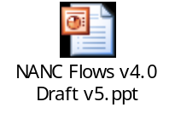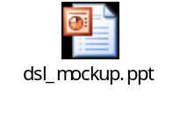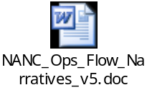

- Review of Action Items and Parking Lot Items – All
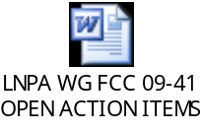

- Discussion of Next Steps – All

- Additional Call/Meeting Scheduling – All

UPCOMING LNPA WG MEETING AND CALL SCHEDULE TO ADDRESS FCC 09-41:

- August 25-26, 2009 face-to-face meeting in Sterling, Virginia, to be hosted by NeuStar
  - Dial-in bridge is 888-412-7808 Pin 23272#
- September 1-2, 2009 face-to-face meeting in Denver, Colorado, to be hosted by Comcast
  - Dial-in bridge is 888-412-7808 Pin 23272#

Next General LNPA WG Meeting …September 15-16, 2009, Philadelphia, Pennsylvania – Hosted by Verizon

