**Meeting Logistics**

**July 9-10, 2019 LNPA TOSC meeting**

 Comcast is pleased to host the July 9th and 10th TOSC meeting in Greenwood Village, CO.

For those TOSC participants who plan to attend the July meeting in person, please submit the following information to [Randee_Ryan@cable.comcast.com](mailto:Randee_Ryan@cable.comcast.com) no later than June 22, 2019. This information will be used to ensure there is sufficient accommodation for participants such as wireless internet access, electrical, seating, and participant access with building security.

Participant Name

Company

Email address

Telephone number

The meeting will be held at:

Comcast

5800 S Quebec St

Greenwood Village, CO 80111

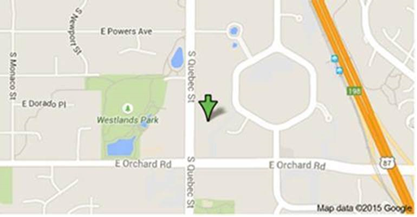

Hotels nearby:

Doubletree by Hilton DTC

7801 E. Orchard Rd. Greenwood Village, CO 80111

[denvertech.doubletree.com](http://denvertech.doubletree.com)

(303) 779-6161

Courtyard Denver Tech Center

6565 South Boston Street

Greenwood Village, Colorado 80111 USA

(303) 721 0300

Denver Marriott Tech Center

4900 S. Syracuse St.

Denver, CO 80237

Hotel: 303.779.1100

Please let me know if there are questions.

Randee Ryan

Sr. Mgr. Industry Relations

Comcast

O - 303-372-2116

C - 720-384-7608