LNPA-WG “Define a Business Day” Team Minutes
Monday, June 29, 2009 11am-1pm (MST)

Sub-Team Chair: Jan Doell - Qwest Communications 303-707-6992 jan.doell@qwest.com

***Note, these are LNPA-WG working-level draft’s and have not been vetted before the full LNPA-WG ***

Upcoming calls:
7/7/09 10 am to noon (Mountain time)
7/21/09 10 am to noon (Mountain time)
Bridge number for all “Define One Business Day” calls:
1-866-789-8820, Meeting ID *1536019* (make sure you put an asterisk before and after ID number)
********************************************************************
The Agreed Upon Goal:
To address how a “business day” should be construed for purposes of the porting interval, and generally how the porting time should be measured (stop and start times of a business day). Also to address FOC interval in relation to the One Business Day

The Team:
Name | Company | Attend?
Jan Doell | Qwest | x
Carolyn Brown | Qwest | x
Tracey Guidotti | AT&T
Ron Steen | AT&T | x
Mark Lancaster | AT&T | x
Lonnie Keck | AT&T | x
Manny Camacho | AT&T
Dave Clippard | AT&T | x
Sue Tiffany | Sprint-Nextel | x
Jim Gampper | Sprint (CLEC) | x
Lavinia Rotaru | Sprint-Nextel
Bonnie Johnson | Integra | x
Linda Peterman | One Communications | x
Gary Sacra | Verizon | x
Deb Trucker | Verizon Wireless | x
Jason Lee | Verizon | x
Cindy Sheehan | Comcast | x
Cindy Williamson | Cox
Dawn Howard | Cox
Jennifer Hutton | Cox
Paula Jordan | T-Mobile | x
Jim Rooks | Neustar
John Nakamura | Neustar | x
Steve Addicks | Neustar | x
Mubeen Saifullah | Neustar | x
Paul Lagattuta | Neustar
Mary Conquest | NuVox | x
Vicki Goth | Embarq | x
Tonya Woods | Embarq | x
Linda Birchem | Fairpoint Comm
Amanda Molina | Townes Comm (represents 8 rural carriers) | x
John McHugh | OPASTCO (represents over 500 mostly small, rural carriers)
Karen Hoffman | JSI (represents over 250 ILEC’s/CLEC’s , ½ rural) | x
Bridget Alexander | JSI | x
Ann Vick | GVNW
Crystal Hanus | GVNW Consulting (represents approx 81 small ILEC’s) | x
Adam Newman | Telcordia | x
Bob Bruce | Syniverse | x
Darla Pistulka | Vantage Point (represent several rural providers in Midwest) | x
Loriann Burke | XO | x
Tiki Gaugler | XO | x
Peggy Rubino | Paetec | x
Brad Lerner | Cavalier | x
Dennis Robins | DER- Consulting (not voting, just observing)
Don Gray | Nebraska PSC (not voting, just observing) | x

“List of Issues Chart” for Tracking Discussion:
This is a list of issues that that have been raised (grouped by similar topical issues and numbered just for ease of reference).

On 6/8/09, the hour was spent in discussion on item 13. The end result was the thought that we needed to do items 4,5,6 first in order to determine when the port had to be ‘ready to port’, and then we could more easily work backward with the necessary intervals/steps.

On 6/22/09 we worked on items 4, 5, 6 and 15. In doing so, I believe I heard consensus reached on item 7, 11, 12, 14, 15 , and 21 as shown below. (Please let me know if you feel I listed something in error.) The team also reached consensus regarding the Time Zone issue. The consensus is as follows: All time zones are local time in the Time Zone of the NPAC Region that the end user telephone number is in. (Example, NPAC Western Region runs on Mountain time, even though it covers Central, Mountain and Pacific time zones. Therefore the time specified for when a valid LSR comes in would be based on Mountain time.)
The end result of the meeting was that there are 5 options that appear to have support amongst the crowd, those options are listed below. Each company was to take these 5 options back internally, rank each of these options with “1” being their favorite and “5” being their least favorite option. The service providers were asked to have their rankings to Jan by close of business on Friday 6/26/09.

The following are the options that the service providers were to rank:
Option A | 8am- 1pm to receive valid LSR  FOC by 5pm (gives maximum 4 hr FOC interval)  Ready for port by 12:01am next business day
Option B | 8am- 2pm to receive valid LSR  FOC by 5pm (gives maximum 3 hour FOC interval)  Ready for port by 12:01am next business day
Option C | 8am- 3pm to receive valid LSR  FOC by 5pm (gives maximum 2 hr FOC interval)  Ready for port by 12:01am next business day
Option D: Chunking Option (which we didn’t fully discuss but seemed to have some interest…) | - Valid LSR in before noon, (FOC interval still negotiated by team), ready for port by 12:01am next business day  - Valid LSR in after noon, (FOC interval still to be negotiated by team), ready for port at noon, next business day
Option E: Rolling 24-hour Due Time Option | - Example, valid LSR in at 2pm, (FOC interval still to be negotiated by team), ready for port at 2pm next business day

On 6/26/09 The completed rankings spreadsheet (see below) was sent to the sub-team and the first hour was spent discussing the results.
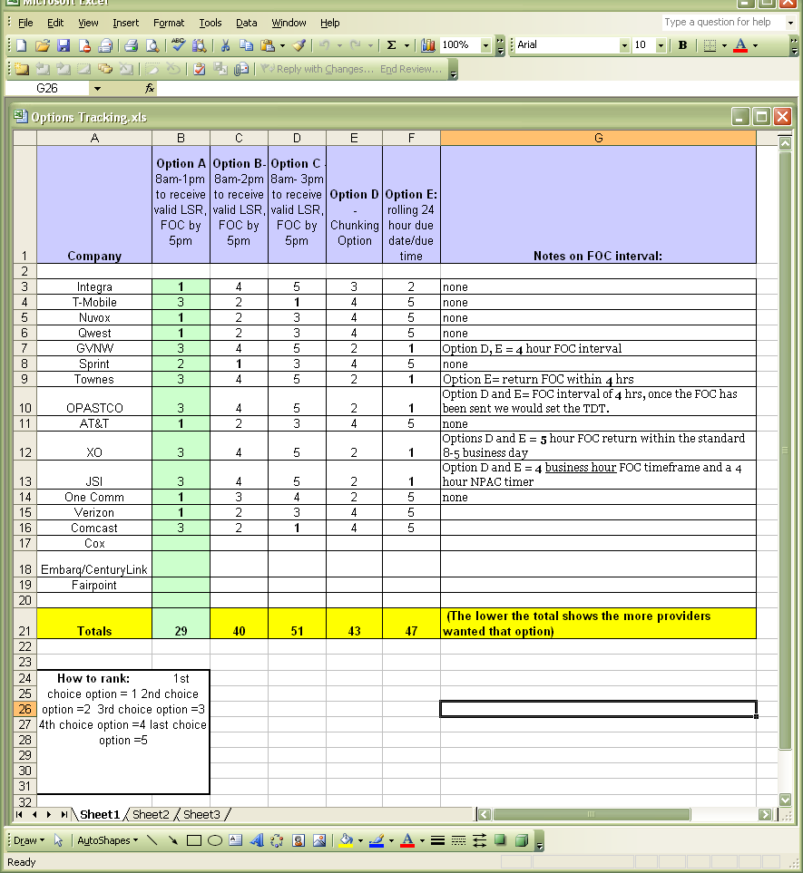
- In evaluating Option E, it was noted that the smaller, mainly rural provider representatives ( 4 of the 5 “1” votes) all liked Option E as they felt it gave them more time for the manual processing and that is the only method they use. It was also noted that several companies (8) has indicated Option 5 as the last option they would choose as it was felt there was no way to effectively manage the 24-hour interval, by individual order.
- In evaluating Option A, it was noted that this was the 1st choice of six providers, some large and some not so large, and it was also noted that no provider selected Option A as its 4th or 5th choice. In group discussion, some of the rural provider associations did say that although Option A was not their first (or even 2nd choice), they felt they could support Option A. There was discussion as to if we could have Option A for providers who used flow-through processing and Option E for those providers who had manual-only processing. But there were parity issues raised that the end users of providers who only processed manually should not be given different/longer interval treatment than those who were associated with automated processing providers. And it was also noted by the rural providers/associations that Option A’s 4 business hours between 1pm and 5pm gave them only 4 business hours to do all the necessary work so the port could happen at 12:01am the following business day. Several providers, even those not choosing Option A, felt it was the best compromise.
- Evaluation of Options B, C and D were not extensive due to the lack of support shown in the ranking.

The end result of the 6/29/09 discussions was to ask the following consensus question: “Does anyone oppose the fact that the process that was used to rank the options was fair, and that the end result points to Option A as the consensus option?” No one opposed this consensus statement, with the exception of one company who thought there may be another/better way to solicit and track the input, but that company could not think of a better way. So Consensus is that Option A is the chosen option of the sub-team. Providers were also instructed by the LNPA-WG co-chairs that when this is brought back into the full LNPA-WG that they had the chance to further discuss concerns. This consensus resolved items 4, 5, 6, 9, 13 and 22.

The rest of the 6/29/09 meeting was spent discussing items 8, 10, 16 and consensus was reached on those items as indicated in the below Issues Chart.
With the remaining time, the sub-team began discussing Item 17 and it was requested of Steve Addicks and John Nakamura of Neustar to prepare a tutorial on how the current conflict time intervals are deployed today to aid in continued discussion of Item 17 in the sub-team meeting on 7/7/09 if possible, or maybe in the LNPA-WG meeting on 7/15/09. Meanwhile providers are encouraged to review all the outstanding items in the chart for discussion in the 7/7/09 call. I have grouped the remaining topics together if they seemed to have a similar topic.

Dependencies? | Status | List of issues
 | Consensus reached | 1.) Old Providers Company-defined Holidays not considered part of a Business Day
 | Fact | 2.) New SP must have FOC before sends SV create to NPAC
 | Consensus reached – one disagreement | 3.) Mandatory Business Day’s are Mon-Fri, (and see #1. above)
 | Consensus reached | 11.) Should business hours be based on OSP ‘processing center’ time zone, NSP processing center time zone, NPAC CST as is today, or end user time zone?  12.) What time zone should business hours be defined in? Should business hours be same for whole country?  Times are based on local time in the Time Zone of the NPAC Region that the end user telephone number is in.  (Example, NPAC Western Region runs on Mountain time, even though it covers Central, Mountain and Pacific time zones. Therefore the time specified for when a valid LSR comes in for the Western NPAC would be based on Mountain time.)
 | Consensus reached | 14.) When does the clock start? Is it at receipt of good LSR?  Yes, a valid LSR starts the clock
 | Consensus reached | 15.) Some think FOC interval/confirmation interval is imbedded in the One Business Day – but some think should be separate.  Good LSR to FOC interval is included in the One Business Day
 | Consensus reached | 7.) Business Hours? Several ranges suggested (8am-3pm, 7am-7pm, 7am-9pm, 8am-5pm  ‘Staffed’ Business hours are 8am-5pm (at a minimum) on a Business Day, local time in the Time Zone of the NPAC Region that the end user is in.
 | Consensus reached | 21.) OSP should not remove the TN from their switch until the NSP activates the TN at NPAC.
 | Consensus reached – one disagreement | 4.) Is One Business Day = to Same Business Day or is it the next business day? (needs to be enough time between good order receipt until ready-to-port)  5.) Rolling 24 hours for due times? (example: good LSR in at 2pm today = 2pm tomorrow due date) Would this infer Hot cuts?  6.) Should the due time be at the End of the Business Day on due date or at 12:01am on due date or???  (see action item BD09-0502)  9.) When does Old SP have to be ready to deliver the port? Is it still at 12:01am on due date, or do we need one full business day to work, or how soon on due date does it have to be ready to port?  13.) Should there be a cut-off time for when an LSR can be submitted and still support a One Business Day interval? Some opinion it needs to be consistent across board.  22.) Should there be a different interval due to Electronic order submission versus manual order submission? What about parity issues? Note: LSR sub-team wants to make sure there is enough time allowed to process LSR/FOC manually.  Consensus is that Option A is the chosen option of the sub-team. 8am- 1pm to receive valid LSR  FOC by 5pm (gives maximum 4 hr FOC interval)  Ready for port by 12:01am next business day (see item 10 below.)
 | Consensus reached | 8.) Do we need a “best effort” port time and a “no-later-than” port time defined?  No, the port ready time is 12:01am (see items 4, 5, 6, 9)
 | Consensus reached | 10.) How do we insure matching “due time” on due date on NPAC SV creates? Current LNPA-WG Best Practice #1 regarding port time on NAPC SV Create to be maintained ‘as is’ at 00:00:00 for Intermodal and wireline-to-wireline Simple Port’s.  http://www.npac.com/cmas/LNPA/best_practices_1.htm  (Note: The sub-team has been talking ‘port ready’ time of 12:01am to insure everyone is clear in our discussion’s that we mean one minute after mid-night. The actual NPAC SV create time is to be 00:00:00)
 | Consensus reached | 16.) FOC interval range? Should there be a set one? If so, suggestions are anywhere between 20 min up to 6 hours, or should it be done by a specific time each day?  Maximum 4 business hour FOC interval
Begin 7/7/09 call here |  | 17.) Should there be a defined Conflict cut-off time? If so, should it be standard across the board?
 |  | 23.) Should old provider be required to concur in NPAC?
 |  | 24.) What should the NPAC T1/T2 timers be for a Simple Port and what time should they run (like 7am-7pm cst)?
 |  | 18.) Triggers have to be set before the port is “ready to port” so as to protect the end users service. When should that happen?
 |  | 20.) Should OSP should not cancel FOC until FOC DD + 3 days has passed (This allows the NSP up to 4 days to activate without a sup?
 |  | 28.) What should happen if request fits the Simple Port requirements, but asks for a longer than one business day due date? Should it still get Simple Port timers and processes, or revert to current longer port timers and processes?
 |  | 19.) Should there be a limit on how many port requests a small provider has to accept in a day, in order to meet the one business day interval? What would that number be? If so, how will they determine who’s port orders gets accepted or rejected if limit is met? Parity concerns?
 |  | 29.) Discuss if all the manual conversion action necessary by a wireless provider when porting-out to a wireline provider, should be cause for a separate set of FOC intervals.
 |  | 25.) Regarding Saturdays, Should we define Business Day with respect to when we can accept receipt of good LSR/FOC?
 |  | 26.) Do we need to also define Business Day different, with respect to the activation? (Saturday issue)
 |  | 27.) Mandate port-out or both port-out/port-in?

Action Items:
BD09-0501: Cindy Sheehan: Find out from NPAC what hours and days the current Wireline and Wireless timers run today. Completed
Wireline (long timers) run Monday – Friday 7:00a.m. to 7:00p.m. CST.
T1= 9 hours, T2= 9 hours
Wireless (short timers) run 7 days a week, 9 am to 9 pm, time zone* varies by region. T1 = 1 hour; T2 = 1 hour
*NPAC timer Time Zones:
Mid-Atlantic, Northeast, Southeast – Eastern
Midwest, Southwest – Central
West Coast – Pacific
Western -Mountain

BD09-0502: For Entire group: Is the “due time” in a due date utilized on orders to the NPAC and between providers? If not, is there a generally agreed upon definition of Due
Time? Completed with Issue 10 consensus
Best Practice #1 says: http://www.npac.com/cmas/LNPA/best_practices_1.htm
- Intermodal time stamp must be midnight GMT (24 hr clock) 00:00:00
- Wireless-to-Wireless says specific times can be set

BD09-0503: The Entire Group: Prepare a one page “white paper” that addresses the
following: Completed
- What you consider a “One Business Day”
- Address if you think FOC included and if so, what interval to assign it
- What are the “stop and start” times should be in defining the business day
- List some examples of different times during the day, (both inside and outside a business day) when orders arrive and when you view the business finished and the port should be completed.
- Talk to whether you think this mandate is on port-in and port-out of just port-out.
- Any other critical issue on the definition to bring up for discussion

5/22/09- AT&T, Comcast and Integra all submitted their contribution papers and they were presented to the group. Clarifying questions were asked of those providers. In the next meeting on 5/28/09, the providers who have not submitted contributions are asked to provide them. We will go through as many of those as is possible.

5/28/09- Verizon, One Communications and Qwest submitted their contributions. In the LNPA-WG call just following our 5/28/09 call, several companies asked to join in on the discussions. Notice was sent to these new attendees and all remaining companies who have not submitted their contributions that if they choose to do so, they need to insure they submit before the June 4th call. Those companies are:
Paula Jordan – T-Mobile
Sue Tiffany/Lavinia Rotaru- Sprint-Nextel
Vicki Goth- Embarq
Linda Birchem – Fairpoint Comm.
Amanda Molina – Townes
John McHugh – OPASTCO
Karen Hoffman – JSI
Dennis Robins – DER- Consulting
Crystal Hanus – GVNW Consulting
Don Gray- NE PSC (monitor calls only, no contribution)

6/4/09- OPASTCO, GVNW, Townes, T-Mobile, Sprint, Fairpoint’s contributions were presented. The following contacts/companies ask to be included in the meetings:
Mary Conquest – NuVox
Jennifer Hutton – Cox
Jim Gampper – Sprint
Lonnie Keck-AT&T
Tonya Woods - Embarq
*********************************************************************

The Cites used to develop the Goal:
FCC 09-41 pp7: As such, we find that the record supports Commission action to reduce the current porting interval for simple wireline-to-wireline and simple intermodal port requests to one business day.30

FCC 09-41 pp8: “We adopt a porting interval in terms of a business day, as opposed to adopting our tentative conclusion that was in terms of hours, to accommodate providers that may not have adequate staffing to handle port requests outside of regular business hours.33”

FCC 09-41 pp10: “We leave it to the industry to work through the mechanics of this new interval. In particular, we direct the NANC to develop new LNP provisioning process flows that take into account this shortened porting interval. In developing these flows, the NANC must address how a “business day” should be construed for purposes of the porting interval, and generally how the porting time should be measured.39

Other Information/Cites discussed:

- NPAC Help Desk Business Hours are Monday – Friday, 7 am – 7 pm Central Time
- NPAC Non-Business Hours are defined as 7:01pm to 6:59am Central Time, Monday through Friday, and all day Saturday and Sunday. During these hours, on call personnel will be provided to assist SMS users if necessary.

- Wireline (long timers) run Monday – Friday 7:00a.m. to 7:00p.m. CST.
T1= 9 hours, T2= 9 hours
- Wireless (short timers) run 7 days a week, 9 am to 9 pm, time zone* varies by *NPAC timer. *Time Zones for Wireless (short) timers:
Mid-Atlantic, Northeast, Southeast – Eastern
Midwest, Southwest – Central
West Coast – Pacific
Western -Mountain
.
- The NPAC looks at the timer selection made by the old SP (the port-out timer) and the new SP (port-in) and selects the one with the longer T1/T2 timers (i.e., the "wireline" timers); it doesn't have concept of "intermodal." For an intermodal port, one of the carriers typically uses the "wireless" timers and the other carrier uses the "wireline" timers, so the NPAC selects the "wireline" timers. I'm not aware of any wireline carrier that has selected wireless timers for its port-in or port-out timers, so I can't imagine a case where anything other than the "wireline" timers would be used by NPAC for an intermodal port. (From Steve Addicks/Neustar)

Meeting Note Information:
Specific meeting notes on what everyone said will not be kept. I will just summarize the action items and any actual agreements and areas to work on, as they come up. I will also show cites as applicable. If someone feels they want notes on what everyone said, they will need to keep them, themselves.

