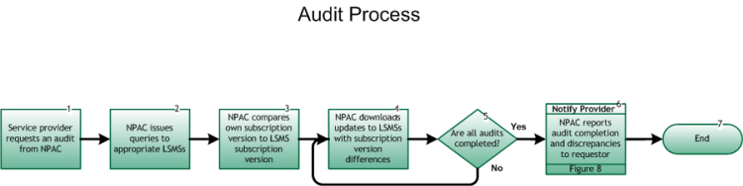

Step 1: Service Provider requests an audit from NPAC
- An SP may request an audit to assist in resolution of a repair problem reported by an End User. Prior to the audit request, the SP completes internal analysis as defined by company procedures and, if another SP is involved, attempts to jointly resolve the trouble in accordance with inter-company agreements between the involved service providers. Failing to resolve the trouble following these activities, the SP requests an audit.

Step 2: NPAC issues queries to appropriate LSMSs
- The NPAC issues queries to the LSMSs involved in the customer port.

Step 3: NPAC compares own subscription version to LSMS subscription version
- Upon receipt of the LSMS subscription version, the comparison of the NPAC and LSMS subscription versions is made to determine if there are discrepancies between the two databases.
- If an LSMS does not respond, it is excluded from the audit.

Step 4: NPAC downloads updates to LSMSs with subscription version differences
- If inaccurate routing data is found, the NPAC broadcasts the correct subscription version data to any involved SPs networks to correct inaccuracies.

Step 5: Are all audits completed?
- If Yes, go to Step 6.
- If No, return to Step 4.

Step 6: Notify Provider – NPAC reports audit completion and discrepancies to requestor
- The NPAC reports to the requesting SP following completion of the audit to allow the SP to close the trouble ticket.
- Upon request, the NPAC provides ad hoc reports to SPs that wish to determine which SPs are launching audit queries to their LSMS. Reseller/Interconnected VoIP Provider/Type 1 Notification, Figure 8.

Step 7: End

