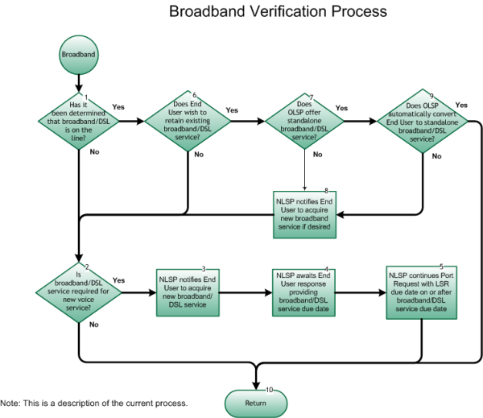

Step 1: Has it been determined that broadband/DSL is on the line?
- If Yes, go to Step 6.
- If No, go to Step 2.

Step 2: Is broadband/DSL service required for new voice service?
- If Yes, go to Step 3.
- If No, go to Step 10.

Step 3: NLSP notifies End User to acquire new broadband/DSL service
- End User could obtain broadband/DSL service from NLSP, if available, or from another service provider.

Step 4: NLSP awaits End User response providing broadband/DSL service due date.
- This is to ensure that End User has obtained the broadband/DSL service that is necessary for their new voice service.

Step 5: NLSP continues Port Request with LSR due date on or after broadband/DSL service due date
- This is to ensure that new broadband/DSL service is available when the port is activated in order for End User to have voice service.

Step 6: Does End User wish to retain existing broadband/DSL service?
- If Yes, go to Step 7.
- If No, go to Step 2.

Step 7: Does OLSP offer standalone broadband/DSL service?
- If Yes, go to Step 9.
- If No, go to Step 8.

Step 8: NLSP notifies End User to acquire new broadband/DSL service if desired.
- Go to Step 2.

Step 9: Does OLSP automatically convert End User to standalone broadband/DSL service?
- If Yes, go to Step 10.
- If No, go to Step 8.

Step 10: Return to Figure 1
- Return to Port Type Determination flow Figure 1, Step 7.

