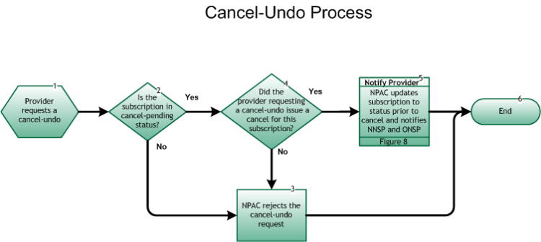

Step 1: Provider requests a cancel-undo
- The Cancel-Pending Undo Process may begin with a Service Provider requesting the reversal (undo) of an in-progress cancel for their cancel-pending port.

Step 2: Is the subscription in cancel-pending status?
- If Yes, go to Step 4.
- If No, go to Step 3.

Step 3: NPAC rejects the cancel-undo request
- NPAC sends an error to the requesting SP indicating the current SV status is not valid for a cancel-undo request.
- Go to Step 6.

Step 4: Did the provider requesting a cancel-undo issue a cancel for this subscription?
- If Yes, go to Step 5.
- If No, repeat Step 3.

Step 5: Notify Provider – NPAC updates subscription to status prior to cancel and notifies NNSP and ONSP
- Upon cancel-undo, NPAC logs this information, and changes the subscription status to the status prior to the cancel (either pending or conflict). Both SPs are notified of the change in the subscription status via the SOA interface.
- For the notification process, refer to Inter-Service Provider LNP Operations Flows – Reseller/Interconnected VoIP Provider/Type 1 Notification, Figure 8 .
- Both SPs take appropriate action related to internal work orders.

Step 6: End

