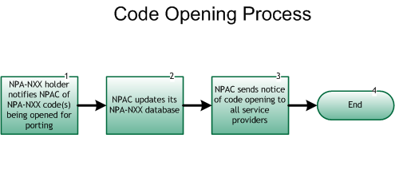

Step 1: NPA-NXX holder notifies NPAC of NPA-NXX Code(s) being opened for porting
- The SP responsible for the NPA-NXX being opened must notify the NPAC via the SOA or LSMS interface within a regionally agreed upon time frame.
- In the case of numbers that use a Type 1 wireless interconnection, the corresponding NPA-NXX needs to be opened by the Old Wireline SP.

Step 2: NPAC updates its NPA-NXX database
- The NPAC updates its databases to indicate that the NPA-NXX has been opened for porting.

Step 3: NPAC sends notice of code opening to all Service Providers
- The NPAC provides advance notice via the object creation message of the scheduled opening of NPA-NXX code(s) via the SOA and LSMS interface. Currently the NPAC vendor is also posting the NPA-NXX openings to the secure website.

Step 4: End

