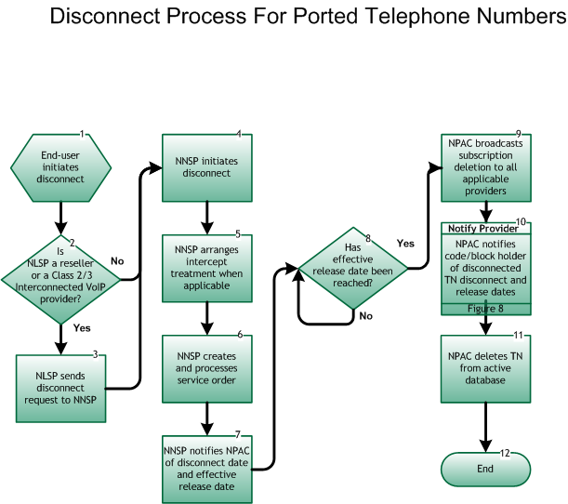

Step 1: End User initiates disconnect
- The End User provides disconnect date and negotiates intercept treatment with current SP.

Step 2: Is NLSP a Reseller or Class 2 or 3 Interconnected VoIP Provider?
- If Yes, go to Step 3.
- If No, go to Step 4.

Step 3: NLSP sends disconnect request to NNSP
- Current Local SP sends disconnect request to current Network SP, per inter-company processes.

Step 4: NNSP initiates disconnect
- NNSP initiates disconnect of service based on request from NLSP or End User.
- NNSP initiates disconnect of service based on regulatory authority(s).

Step 5: NNSP arranges intercept treatment when applicable
- NNSP arranges intercept treatment as negotiated with the end user, or, when the disconnect is SP initiated, per internal processes.

Step 6: NNSP creates and processes service order
- NNSP follows existing internal process flows to ensure the disconnect within its own systems.

Step 7: NNSP notifies NPAC of disconnect date1 and indicates effective release date2
- NNSP notifies NPAC of disconnect date via the SOA interface and indicates effective release date, which defines when the broadcast occurs.
- If no effective release date is given, the broadcast from the NPAC is immediate. The maximum interval between disconnect date and effective release date is 18 months.

Step 8: Has effective release date been reached?
- If Yes, go to Step 9.
- If No, repeat Step 8

Step 9: NPAC broadcasts subscription deletion to all applicable providers
- On effective release date, the NPAC broadcasts SV deletion to all applicable SPs via the LSMS interface.

Step 10: Notify Provider – NPAC notifies code/block holder of disconnected TN(s), disconnect and release dates
- On effective release date, the NPAC notifies code/block holder of the disconnected TN(s), effective release and disconnect dates via the SOA interface. Reseller/Interconnected VoIP Provider/Type 1 Notification, Figure 8.

Step 11: NPAC deletes TN(s) from active database
- On effective release date, the NPAC removes telephone number from NPAC database.

Step 12: End

Footer
1 Disconnect Date: Date the telephone number or numbers are no longer associated between an End User and the current Service Provider.
2 Effective Release Date: Date the telephone number reverts back to NPA/NXX holder/owner.

