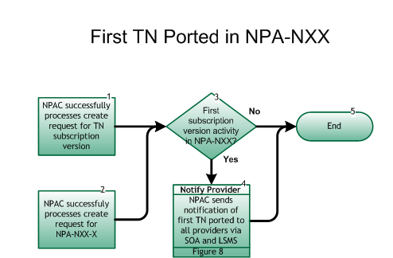

**Step 1:  NPAC successfully processes create request for TN subscription version**

* SP notifies the NPAC of SV creation for a TN in an NPA-NXX.

**Step 2:  NPAC successfully processes create request for NPA-NXX-X**

* NPAC successfully processes an NPA-NXX-X for a Number Pool Block.

**Step 3:  First Subscription Version activity in NPA-NXX?**

* If Yes, go to Step 4.
* If No, go to Step 5.

**Step 4:  Notify Provider – NPAC sends notification of first TN ported to all providers via SOA and LSMS**

* When the NPAC receives the first SV create request in an NPA-NXX, it will broadcast a “heads-up” notification to all SPs via the SOA and LSMS interfaces.  Upon receipt of the NPAC message, all SPs will complete the opening for the NPA-NXX code for porting in all switches.
* [**Reseller/Interconnected VoIP Provider/Type 1 Notification, Figure 8.**](https://workinggroup.numberportability.com/documents/resellerinterconnected-voip-providertype-1-notification-process)

**Step 5:  End**