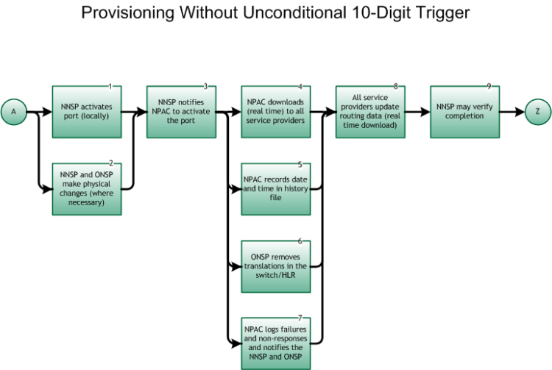

Please note, Steps 1 and 2 ARE worked concurrently

Step 1: NNSP activates port (locally)
- This is the entry point from the Inter-Service Provider LNP Operations Flows – Main Porting Flow, tie point A, Figure 6.
- The Wireline NNSP activates its own switch translations.
- As an optional step, the Wireless NNSP activates its own switch/HLR configuration including assignment of Mobile Station Identifier (MSID).

Please note, Steps 2 and 3 MAY be worked concurrently.

Step 2: NNSP and ONSP make physical changes (where necessary)
- Wireline physical changes may or may not be coordinated. Coordinated physical changes are based on inter-connection agreements between the involved service providers.
- Mobile Station (handset) changes are completed.
- The NNSP is now providing dial tone to ported end user.

Step 3: NNSP notifies NPAC to activate the port
- The NNSP sends an activate message to the NPAC via the SOA interface.
- No NPAC SV may activate before the FOC due date/time. Unless otherwise agreed to between both porting parties (ONSP and NNSP) the SV Due Date is the FOC due date agreed upon between the ONSP and NNSP.
- If not done in step 1 above, the Wireless NNSP activates its own switch/HLR configuration including assignment of Mobile Station Identifier (MSID).

Please note, Steps 4, 5, 6, and 7 may be concurrent, but at a minimum should be completed ASAP.

Step 4: NPAC downloads (real time) to all service providers
- The NPAC broadcasts new SV data to all SP LSMSs in the serving area in accordance with the NANC FRS and NANC IIS. The Service Control Point (SCP) Applications and Global Title Translations (GTT) Function for Number Portability requirements are defined by T1S1.6.

Step 5: NPAC records date and time in history file
- The NPAC records the current date and time as the Activation Date and Time stamp, at the start of the broadcast. The Activation Complete Timestamp is based on the first LSMS that successfully acknowledged receipt of new SV.

Step 6: ONSP removes translations in the switch/HLR
- The Wireline ONSP initiates the removal of translations either at designated Due Date and Time, or if the order was designated as coordinated, upon receipt of a call from the NNSP.
- The Wireless ONSP initiates the removal of the subscriber record from the switch/HLR after the activation of the port.
- It is necessary for the OLSP to terminate the End User’s service for the ported TN(s) after the port is completed.

Step 7: NPAC logs failures and non-responses and notifies the NNSP and ONSP
- The NPAC resends the activation to an LSMS that did not acknowledge receipt of the request, based on the retry tunable and retry interval. The number of NPAC SMS attempts to send is a tunable parameter for which the current setting is one (1) attempt, in which case no retry attempts are performed. Once this cycle is completed, NPAC personnel, when requested, investigate possible problems. In addition, the NPAC sends a Notification via the SOA interface to both NNSP and ONSP with a list of LSMSs that failed activation.

Step 8: All service providers update routing databases (real time download)
- This is an internal process and is performed in accordance with the Service Control Point (SCP) Applications and GTT Function for Number Portability requirements as defined by ATIS T1S1.6 (within 15 minutes).

Step 9: NNSP may verify completion
- The NNSP may make test calls to verify that calls to ported numbers complete as expected.

Step 10: End
- Return to Main Porting Flow, tie point Z, Figure 6.

