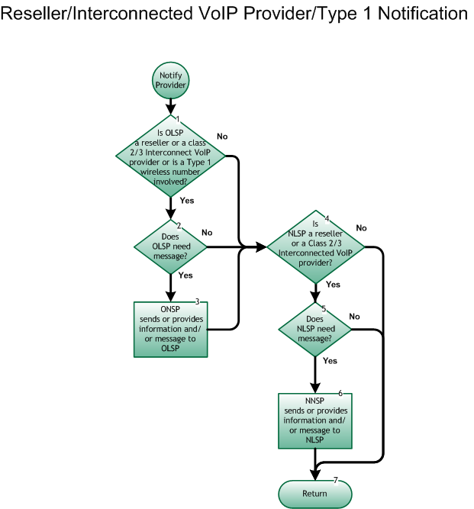

**Step 1:  Is OLSP a Reseller or a Class 2 or 3 Interconnected VoIP Provider or is a Type 1 wireless number involved?**

* If Yes, go to Step 2.
* If No, go to Step 4.

**Step 2:  Does OLSP need message?**

* If Yes, go to Step 3.
* If No, go to Step 4.

**Step 3:  ONSP sends or provides information and/or message to OLSP**

* ONSP (Network Provider) sends or provides information and/or message to the OLSP (Reseller or Class 2/3 Interconnected VoIP Provider or wireline provider providing Type 1 arrangement) fulfilling all requirements of any service agreement between the involved service providers.

**Step 4:  Is NLSP a Reseller or Class 2 or 3 Interconnected VoIP Provider?**

* If Yes, go to Step 5.
* If No, go to Step 7.

**Step 5:  Does NLSP need message?**

* If Yes, go to Step 6.
* If No, go to Step 7.

**Step 6:  NNSP sends or provides information and/or message to NLSP**

* NNSP (Network Provider) sends or provides information and/or message to the NLSP (Reseller or Class 2 or 3 Interconnected VoIP Provider) fulfilling all requirements of any service agreement between the involved service providers.

**Step 7:  Return**

* [**Return to previous flow.**](https://workinggroup.numberportability.com/documents/subscription-version-create-process)