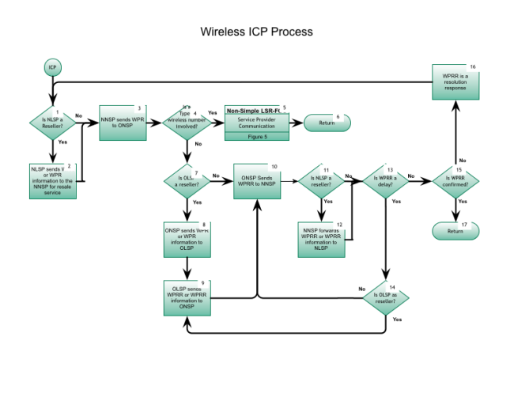

Step 1: Is NLSP a Reseller?
- This is the entry point from the Inter-Service Provider LNP Operations Flows – Port Type Determination, Figure 1, Step 5 .
- The NLSP determines if customer is porting all TN(s).
- If Yes, go to Step 2.
- If No, go to Step 3.

Step 2: NLSP sends WPR or WPR information to NNSP for resale service
- NLSP (Reseller) sends a WPR (Wireless Port Request) or WPR information to the NNSP (may vary slightly depending on provider agreement between the involved service providers).
- For wireless to wireless service providers the WPR/WPRR (Wireless Port Request/Wireless Port Request Response) initial response time frame is 30 minutes.
- The due date for a TN ported in an NPA-NXX which has TNs already ported is no earlier than 2 business hours after a confirming WPRR receipt date/time or as currently determined by NANC.

Step 3: NNSP sends WPR to ONSP
- The NNSP notifies the ONSP of the port request using the WPR.
- ICP response interval, currently set to 30 minutes, begins from acknowledgment being received by NNSP from ONSP, and not at the time the WPR is sent from the NNSP to the ONSP.

Step 4: Is a Type 1 wireless number involved?
- If Yes, go to Step 5.
- If No, go to Step 7.

Step 5: NON-SIMPLE LSR-FOC – Service Provider Communication
- Inter-Service Provider LNP Operations Flows - Wireline Non-Simple Port LSR/FOC Process , Figure 5, Step 1.

Step 6: Return to Figure 1
- Return to Port Type Determination flow Figure 1, Step 5 .

Step 7: Is OLSP a Reseller?
- If Yes, go to Step 8.
- If No, go to Step10.

Step 8: ONSP sends WPR or WPR information to OLSP
- The ONSP notifies the OLSP of the port request using the WPR or WPR information.

Step 9: OLSP sends WPRR or WPRR information to ONSP
- The OLSP sends the ONSP the WPRR or WPRR information.

Step 10: ONSP sends WPRR to NNSP
- ONSP sends the WPRR to the NNSP.
- IC terminates upon receipt of WPRR by NNSP.

Step 11: Is NLSP a Reseller?
- If Yes, go to Step 12.
- If No, go to Step 13.

Step 12: NNSP forwards WPRR or WPRR information to NLSP
- The NNSP sends the WPRR or WPRR information to the NLSP.

Step 13: Is WPRR a Delay?
- If Yes, go to Step 14.
- If No, go to Step 15.

Step 14: Is OLSP a Reseller?
- If Yes, go to Step 9.
- If No, go to Step 10.

Step 15: Is WPRR confirmed?
- If Yes, go to Step 17.
- If No, go to Step 16 – WPRR must be a Resolution Required.

Step 16: WPRR is a resolution response
- Return to Step 1.
Step 17: Return to Figure 1
- Return to Port Type Determination flow Figure 1, Step 5 .

